Web Service Bridge

The webservice that is required is a Bridge between the User who consumes the service and the Server where the requested information is extracted, for this we will define some terms:

1) ***User who consumes the service***: this user identifies himself to the service with a Username and password ( <User> and <Password> ) together with these authentication data sends the parameters of the information request that he requires.

2) **Pass-through server**: It is the server where the "Bridge WebService" will be installed and who receives the call from the "User that consumes the service" and who makes the call to the "Provider Server" This server runs Apache TomCat and has a ORACLE database.

1. ***Provider Server***: It is the server of the company "TransUnion" which is the one who provides the information. Calls to this server are made through XML (see documentation)

Bridge WebService Description

1) Wait for the service call

1. It receives a call with the following XML structure, the first two parameters identify the ***User who consumes the service* <User>** and **<Password>**, these two parameters are validated if they are in the text file called **Cuentas.txt**

|  |  |  |
| --- | --- | --- |
| **Tag XML** | **Required** | **Type** |
| <User> | YES | String |
| <Password> | YES | String |
| <codigoInformacion> | YES | String |
| <tipoIdentificacion> | YES | String |
| <numeroIdentificacion> | YES | String |
| <primerApellido> | YES | String |
| <motivoConsulta> | YES | String |

1. It performs the Authentication of the system before the ***Provider Server*** (TransUnion) through the <UserNameTransUnion> and <PasswordTransUnion>, these two parameters are taken from the text file called **CuentaTransUnion.txt**

**Before sends the SOAP request to the *Provider Server*** (TransUnion)**, the web service must have authenticated itself with the TransUnion application server. This authentication corresponds to a BASIC-type authentication with username and password (Identification and password).**

**If the validation is successful, the client can proceed with the service invocation (query execution). Otherwise, for any operation that is executed, the system will return the 401 Unauthorized message.**

1. The Tags <User> and <Password> are removed from the structure of the call and the rest is sent to the ***Provider Server*** as an API call via HTTPS, to one of the following URLs:

* URL of the service in the test environment:  
  <https://miportafoliouat.transunion.co/ws/UbicaPlusWebService/services/UbicaPlus>
* WSDL URL in test environment: <https://miportafoliouat.transunion.co/ws/UbicaPlusWebService/services/UbicaPlus?wsdl>
* Service URL in the production environment: https://miportafolio.transunion.co/ws/UbicaPlusWebService/services/UbicaPlus
* WSDL URL in the production environment: https://miportafoliouat.transunion.co/ws/UbicaPlusWebService/services/UbicaPlus?wsdl

Both environments use HTTPS protocol (port 443) and support TLS 1.2 protocol (TLS 1.0 and 1.1

disabled). (see documentation)

|  |  |  |
| --- | --- | --- |
| **Tag XML** | **Required** | **Type** |
| **<codigoInformacion>** | YES | String |
| **<tipoIdentificacion>** | YES | String |
| **<numeroIdentificacion>** | YES | String |
| **<primerApellido>** | YES | String |
| **<motivoConsulta>** | YES | String |

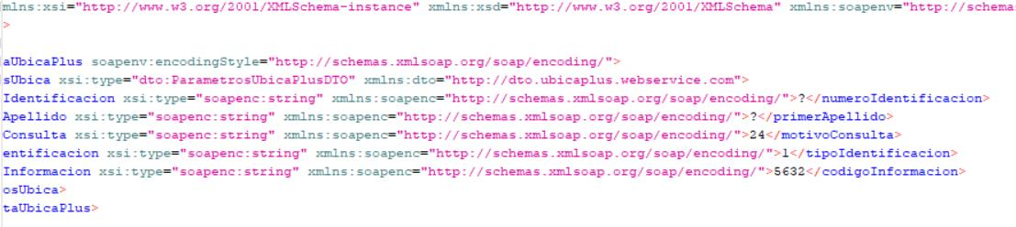

|  |  |  |
| --- | --- | --- |
| **Tag XML** | **Type** | **Long** |
| <codigoCiiu> | Integer | 6 |
| <codigoDepartamento> | Integer | 6 |
| <codigoMunicipio> | Integer | 6 |
| <codigoTipoIndentificacion> | Integer | 2 |
| <entidad> | String | 60 |
| <estado> | String | 20 |
| <fecha> | Date |  |
| <fechaExpedicion> | Date | 20 |
| <hora> | Time |  |
| <identificadorLinea> | Integer | 15 |
| <lugarExpedicion> | String | 20 |
| <nombreCiiu> | String | 60 |
| <nombreTitular> | String | 60 |
| <numeroIdentificacion> | Integer | 15 |
| <rangoEdad> | String | 6 |
| <respuestaConsulta> | Integer | 2 |
| <tercero> |  |  |
| <tipoIdentificacion> | String | 6 |
| <UbicaPlusCifin> |  |  |

5) The ***Provider Server*** responds with this structure:

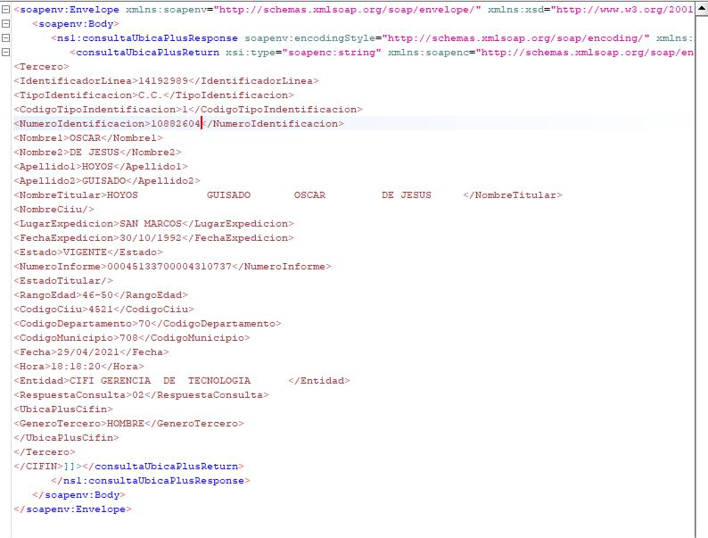

6) The response as it arrives is sent to the ***User who consumes the service*** and is saved in a database record (SQL "INSERT INTO XXXXX" )..

To carry out the contract, the payments would be as follows:

When you make the part of the call to the Provider Server and get a response, a first disbursement of 40% of the value

When you do the Pass-through server Webservice and it calls the Provider Server 30%

And 30% after the delivery of the fully functional program (tests will be carried out at each stage) and the documentation of the service, the balance of the contract

*******************************  
**Pass-through server:**

<https://conexionvpn.laequidadseguros.coop/showLogon.do?>

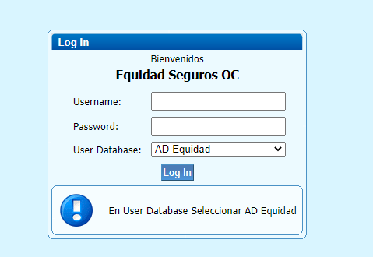

Username: telepresencia

Password: Equidad*2220

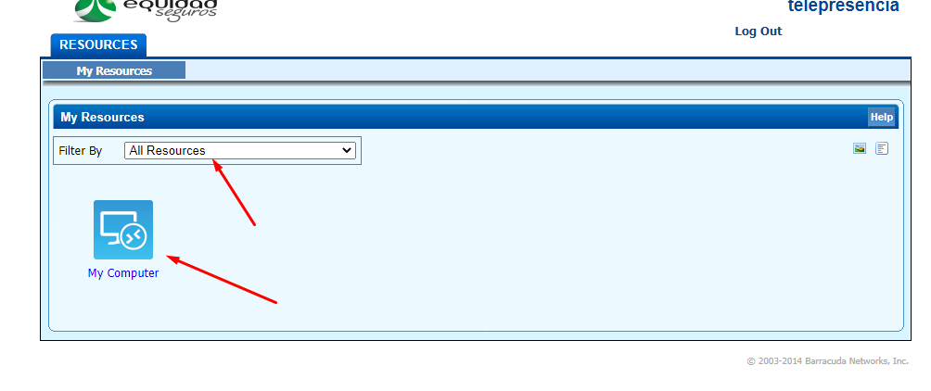

Download SSL VPN Agent  
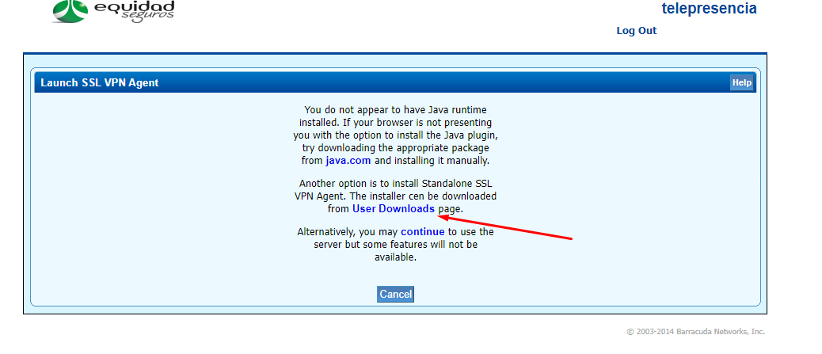

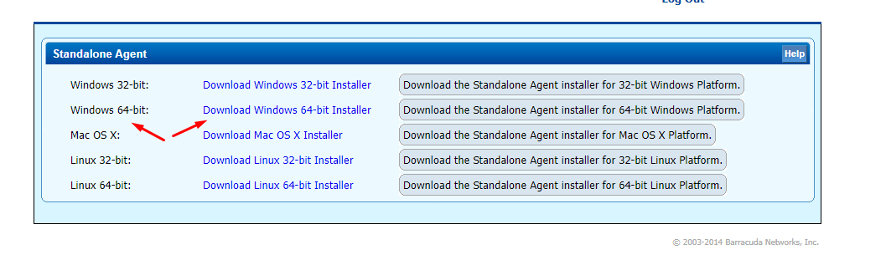

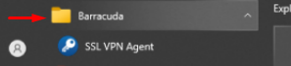



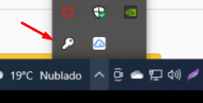

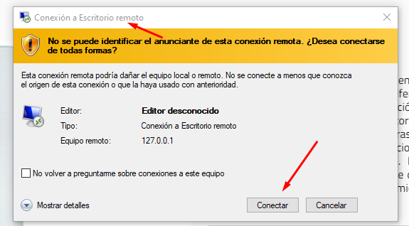

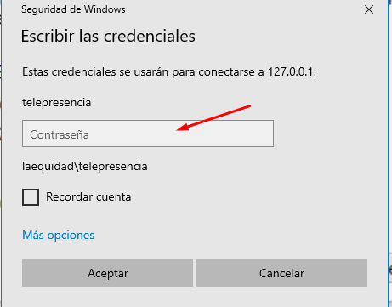

Password: Equidad*2220